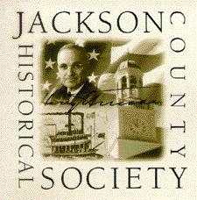 | Jackson County Historical Society  Dedicated to the future of the past.

Deed of Gift

Donor Information (please print)

Name

Street Address

City, ST, Zip Code

Phone 1 | Phone 2

Email

Donation Information
I (we) donate the following items to JCHS:

Stipulated terms of gift _______________________________________________________________________________________________________________

Disposition of any gift item not needed in our collection __________________________________________________________________________

Accession Number_____________________________________________________________________________________________________________________

Collection Name (if applicable)_______________________________________________________________________________________________________

Acknowledgement Information

Please use the following name(s) in all acknowledgements: ______

By signing the Deed of Gift, I understand that this is an irrevocable and unconditional gift to JCHS.

Signature(s) |  | Date

Jackson County Historical Society Received by JCHS DATE _________________________________________
112 W. Lexington, Room 120
Independence, MO 64059 Name of JCHS Representative _____________________________________
816461-1897 www.jchs.org

